American Institute for Professional Geologist End of Year Report
Wayne State University
Faculty Advisor
Dr. Scott Burdick
Email: sburdick@wayne.edu
Officers 2020-2021
President: Breauna Murray
Vice President: Julia Jackenon
Treasurer: Rahima Tufail
Secretary: Sasha LaPonsa
Officers 2021-2022
President: Breauna Murray
Vice President: Rahima Tufail
Treasurer: Kelsey Hewett
Secretary: Julia Jackenon

Number of Chapter Meetings per: Once a month
During this year we were unable to hold any events due to the COVID-19 pandemic. Wayne State University made a decision that meetings in person for student organization would be prohibited. Due to this, club participation was low. Therefore, over the year we meet online through zoom meetings. We were able to hold events such as field camp seminars, Rock show and Tell, Netflix Movie Night, Jeopardy and Etc.
We are proud to announce that our chapter president, Breauna Murray, was the recipient of the AIPG National Undergraduate Scholarship for the 2021 year. We’re especially proud of our chapter for this achievement, for this is the second chapter member in the last 2 years (past chapter president, Kelsey Hewet, 2019) to be recognized for this prestigious award.
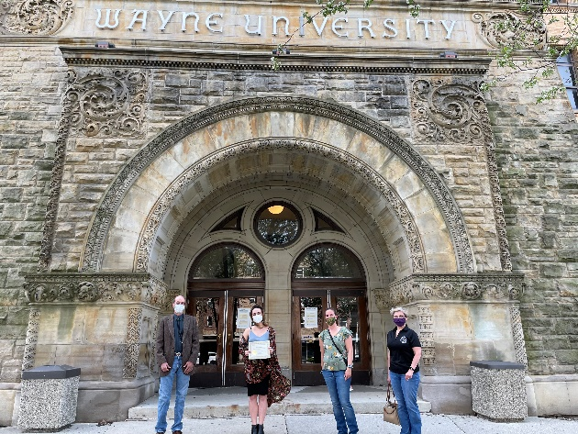
Roster of Student Members:

Johnny Alsaigh gh3559@wayne.edu
Brendan Alvis gd7038@wayne.edu
Andrea Bartlett gq7279@wayne.edu
Olivia Card gh0594@wayne.edu
Ellie Carlson gj4096@wayne.edu
Rahana Chowdhory gh7127@wayne.edu
Alex Eklund cq7777@wayne.edu
Teagan Evans gq1938@wayne.edu
Gregory Ferreira gq1938@wayne.edu
Erik Fleissner erikfleissner@wayne.edu
Kelly Garcia cn3546@wayne.edu
Kevin Green fi8735@wayne.edu
Kelsey Hewett gj4463@wayne.edu
Erin Ivers fp4639@wayne.edu
Julia Jackenon fh2822@wayne.edu
Devyn Jesiel gk7335@wayne.edu
Liana Jones ga3056@wayne.edu
Gwen Klenke gr2274@wayne.edu
Daniel Kozlowski gd8860@wayne.edu
Tyler McDermott gj6011@wayne.edu
Erin McNally ft9069@wayne.edu
Sophia Mekled gi5113@wayne.edu
Kyle Merandi kylemerandi@wayne.edu
Haylee Miller gv9081@wayne.edu
Hannah Monear fz2128@wayne.edu
Breauna Murray gh3800@wayne.edu
Ashlee Oaks gq4416@wayne.edu
Nathaniel Okkonen gw4488@wayne.edu
Hailey Peace gp3806@wayne.edu
Taylor Pine ga7722@wayne.edu
Matthew Piziali gh8707@wayne.edu
Charles Sind go8615@wayne.edu
Austin Smithberger fh8031@wayne.edu
Eamheng Taing ef8984@wayne.edu
Shana Totten gk3147@wayne.edu
Rahima Tufail gp4205@wayne.edu
Kourtney Dole kourtney.dole@wayne.edu
Danielle Donovan gf9849@wayne.edu
Michael VanPoepeghem fh0108@wayne.edu
Mary Whitefield gu6118@wayne.edu
Shelby Wilson gy3496@wayne.edu
Justin Yarrington gv9840@wayne.edu
Lathan Saperstein ea1022@wayne.edu
Elijah McCoy gi1376@wayne.edu
Benediktas Gaskevies ge9633@wayne.edu
Diana Torres gp5784@wayne.edu
Denada Planaj dplanaj@wayne.edu
Benjamin Moyer blmoyer@wayne.edu
Paul Manion pmanion@wayne.edu
Jonas Sikah jonassikah@wayne.edu
Stefan Smolenski stefan.smolenski@gmail.com

